**EXCERISE – LAB 04**

Q1 & Q2

Q3. Obtain boxplot for sales and interpret the shape of the sales distribution

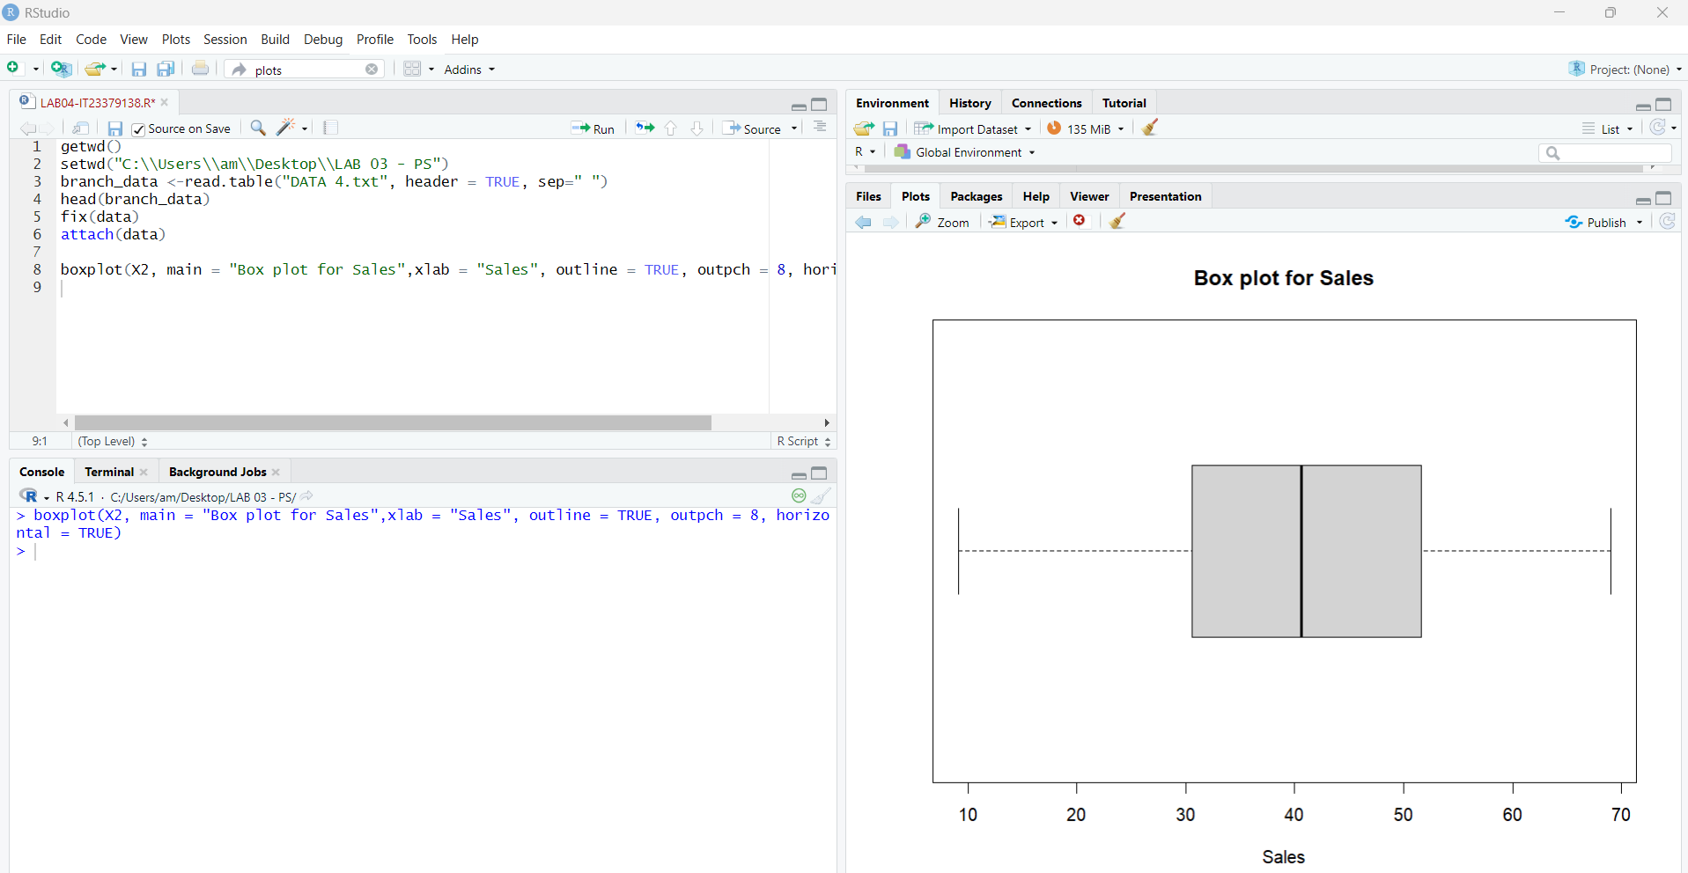

Q4. Calculate the five number summary and IQR for advertising variable.

Q5. Write an R function to find the outliers in a numeric vector and check for outliers in years variables.

